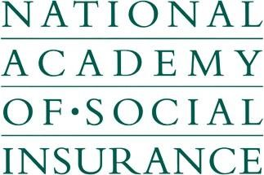
INTERNSHIP APPLICATION
Please indicate which internship you are applying for:
☐ Merton C. Bernstein Internship on Social Insurance
☐ Eileen Sweeney Graduate Internship in Disability Policy
☐ Anne Somers Aging and Long-Term Care Research Internship
☐ Rashi Fein Internship in Health Policy
☐ All
Name:
Street Address:
City: State: Zip:
Contact Number: (Home)
(Cell)
E-mail address:
University:
Major:
Year of graduation: (Actual or Projected)
GPA: (Official Transcript Required)

Relevant work experience, internships, and/or academic assignments:

Personal computer skills or software with which you have experience:

Where did you hear about the Academy’s internship programs?

Please submit this form with the following materials:
1) A one-page cover letter that explains your interest in the internship program and answers the following questions:
- In your own words, how would you define social insurance and its role in your family’s life?
- To what extent have you studied social insurance programs?
- What special skills or qualifications will you bring to your placement?
- On what types of assignments do you perform best? (e.g. research, writing, statistics, computer applications, organizing etc.)
- How will this experience relate to your future career plans?
- Resume
- Official transcript (if you are a graduate student, submit a copy of your undergraduate and graduate course work to date)
- Three professional and/or academic written letters of recommendation with contact information
- A five to ten page writing sample which reflects the type and quality of work you have done

Mail to:

Internship Programs
National Academy of Social Insurance
1200 New Hampshire Ave., NW, Suite 830
Washington, DC 20036-6802

Or email to: internships@nasi.org

Application and materials must be received by February 1, 2019.

Applications will be considered incomplete if any information is missing as of the deadline.

Completed applications will be considered by the selection committees for placements in Washington, DC that begin in either May or June.

For additional information visit our website at www.nasi.org and our Internship Opportunities page, or contact us at (202) 452-8097 or internships@nasi.org.

