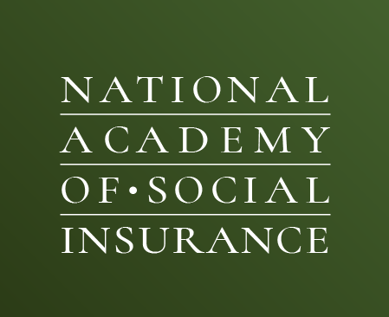

Internship Placement Application Form
Use this form to request an intern for Summer 2024

Name:

Title:

Organization:

Phone: Email:

My organization is interested in hosting an Academy intern for approximately 10-12 weeks (May/June
through August/September 2024). Academy 2023 programs were 100% in-person. Based on current public health guidance, we will continue full in person programming for 2024.

Our ideal start date for an intern is: _______________
We operate: (circle below)

Fully In Person Hybrid with #___ days in office Fully Remote

Please indicate which Academy internship program fits with your organization’s needs: (Click here for a description of each program)

John Burton Internship on Workers’ Compensation Research and Policy

Rashi Fein Internship in Health Policy
Leeba Lessin Internship on Health and Medicare Policy
Somers Aging and Long-Term Care Research Internship (research and writing focus)
Congressman Pete Stark Health Policy Internship (graduate students only)
Eileen Sweeney Graduate Internship in Disability Policy
Merton C. Bernstein Internship on Social Insurance

Will you supervise the Academy intern personally?

 | Yes |  | No

If not, who will be supervising the Academy Intern?

Name:

Phone: Email:

Department in which intern would work: _________________________________________________

Work Description
(Or please attach an existing intern position description if you have one.)

What are the essential functions you might expect the intern to perform?
(We appreciate as much detail as possible to ensure a suitable match between prospective interns and your organization.)

Are you prepared to provide reasonable accommodations for a qualified applicant with a disability? __________

Intern qualifications: (Please note if required (r) or preferred (p).

Undergraduate or Graduate:

Prior course work:

Computer skills:

Other necessary qualifications:

Program funding: As of 2021, the Academy is compensating interns in our program according to Washington, DC’s minimum wage ($17.50/hour as of July 1, 2024). Depending on how many hours a week an intern works (35-40 hours/week) and how many weeks (10-12 weeks), the amount each student earns may range from $6,125-$8,400 for the summer. The Academy’s total cost (including recruitment, placement, and ongoing support to each intern throughout the summer program) is substantially more than the honorarium that interns receive.

Will your organization be able to contribute at least the respective amount within the above range to cover your intern’s honorarium? _______________________________

Will your organization be able to contribute beyond the honorarium to help cover the full cost of the program? If yes, what is the total amount you will be able to contribute? ____________________________________

If you have a limited budget, please indicate what amount you will be able to contribute (by June 30, 2024).
__________________________________

The Academy is committed to providing the best possible professional experience for each intern. Lack of funding will not disqualify promising placement opportunities, but adequate funding is taken into consideration as we determine the size of the 2024 cohort and how many students we will serve. Thank you for your support.

The preferential deadline to request an intern is Friday, March 1st, 2024.
Please send your completed form by e-mail to ajailal@nasi.org. Thank you!

Ariella Jailal
Manager of Leadership Development and External Affairs
National Academy of Social Insurance
1441 L Street, NW, Suite 530
Washington, DC 20005
202.243.7282

